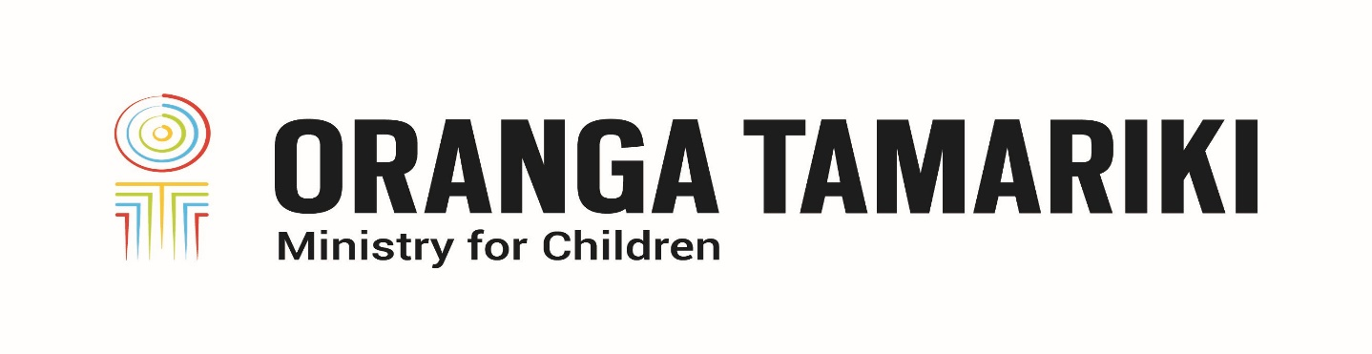
Oranga Tamariki Disability Vision and Strategy
Adapted in 2023 by Accessible Formats Service,
Blind Low Vision NZ, Auckland
TN: Logo on the top of the page is: Oranga Tamariki Ministry for Children.

Oranga Tamariki Disability Vision and Strategy
Our vision was developed in partnership with disabled people, their champions, tāngata whaikaha Māori and care experienced rangatahi.

Our vision
"The mana of tāngata whaikaha me o ratou toa (disabled people and their champions) is enhanced by meeting their needs, upholding their rights and supporting their hopes and dreams."

What our vision means
Tāngata whaikaha are experts in their own lives and the best source of their own solutions. Our focus is shifting to how we best support tāngata whaikaha me o ratou toa to achieve their hopes, dreams, goals, and aspirations. We will respect and uphold their priorities and aspirations, not speak on their behalf, about them, or for them, and meet their needs and rights in a collaborative and user-friendly way.

How the vision will become a reality
To achieve our vision, we have identified four shifts that need to occur:
- Oranga Tamariki takes a whole of life approach to disability, understanding that disability is only one component of who tāngata whaikaha are, and that disability can be a collective experience for tāngata whaikaha me o ratou toa.
- Tāngata whaikaha me o ratou toa experience connected, rights based, consistent and transparent children's and disability systems.
- The Oranga Tamariki workforce have the skills and expertise, including cultural competency, to work with tāngata whaikaha me o ratou toa.
- Tāngata whaikaha me o ratou toa experience a safe and proactive Oranga Tamariki.

Our draft definition of disability
Disabled people are people who have long-term physical, cognitive, intellectual, neurological, or sensory impairments including neurodiverse conditions, such as Fetal Alcohol Spectrum Disorder (FASD), Autism Spectrum Disorder (ASD) and Attention Deficit Hyperactivity Disorder (ADHD), which in interaction with various barriers, may hinder their full and effective participation in society on an equal basis with others.
Tāngata whaikaha me o ratou toa refers to disabled people and their whānau, carers, iwi, and community—their champions. We take a collective view, recognising that although individuals have impairments, they are part of a whānau or a family, and part of an iwi or a community.
End of Oranga Tamariki Disability Vision and Strategy

